BMS

A **Battery Management System (BMS)** is an electronic system used in battery-powered applications.

Used in electric vehicles (EVs), energy storage systems, and portable electronics.

Its main role is to **monitor, control, protect, and optimize** the performance and health of a battery pack.

Functions of BMS

**Monitoring**:

Tracks voltage, current, and temperature of each cell/module.

To know the health and safety condition of every cell.

**Protection**:

Uses relays or MOSFETs to disconnect the battery if:

Overvoltage, Undervoltage, Overcurrent, Overtemperature, to **protect the battery from damage**.

**Balancing**:

If one cell is overcharged or undercharged compared to others, this section:

Uses passive method: burns off extra energy using resistors,

Or active method: transfers extra energy to other cells,

to keep all cells at the **same level of charge** for safety, better performance, and longer life.

**Communication**:

Sends real-time battery data to external systems via protocols like CAN, UART, etc., to communicate battery health or warnings.

BMS Architecture

BMS typically consists of

**a) Sensing Circuit : AFE**

Measures cell voltages, pack current, and temperatures using sensors and ADCs.

**b) Microcontroller (MCU) / Control Unit**

It takes all the measured data and makes decisions like:

* Is any cell overcharging?
* Is it overheating?
* Should we turn off charging/discharging?
* Should we do **cell balancing**

**c) Protection Circuit**

Uses switches (e.g., MOSFETs or relays) to isolate the battery pack under fault conditions like:

* Overvoltage
* Undervoltage
* Overcurrent
* Overtemperature

**d) Cell Balancing Circuit**

* Ensures all cells maintain equal voltage levels to maximize battery capacity and lifecycle.
* Two main types:
  + **Passive Balancing**: Removes excess charge of higher voltage cells by converting it into heat using resistors.
  + **Active Balancing**: Transfers charge from higher voltage cells to lower voltage cells using inductors, capacitors, etc.

**e) Communication Interface**

Sends real-time battery data to external systems via protocols like CAN, UART, etc., to communicate battery health or warnings.

Role of Cell Balancing in BMS

Some cells get more charged and some cells get less charged. So to equalize the charge in all cells so they work properly together and safely, we need cell balancing.

**Cell imbalance can cause:**

* 1. Overcharging and discharging of cells on regular basis which can damage cells.
  2. The battery pack cannot give full capacity.
  3. The battery lifecycle damages.

**Why cells discharge or overcharge?**

* 1. It could be manufacturing difference
  2. No two cells are identical
  3. Internal resistance, capacitance, self discharge rate
  4. Temperature Variations
  5. Aging

**Why cell balancing is needed?**

* 1. To improve battery performance and capacity
  2. Extend battery life
  3. Avoid over charging or discharging of cells
  4. Ensure safety

**Methods used for cell balancing:**

* + 1. **Active cell balancing**

Extra energy is removed from over charged cells and transferred to less charged cells using inductors or transformers etc. used for HV applications.

It is energy efficient and costly.

* + 1. **Passive cell balancing**

Removes extra charge from over charged cells and convert it into heat to burn it off using resistors.

It is simple for application and cheap

Active cell balancing

Active Cell Balancing is a technique that transfers energy between battery cells to equalize their charge levels. This is done using- capacitors, inductors, switched converter circuits

**Capacitor based balancing**- uses a flying capacitor that charges from a high voltage cell and discharges into a lower voltage cell.

**Inductor based balancing**- uses an inductor to temporarily store energy from one cell and transfer it to another.

**Converter based balancing**- each cell connects to acentral energy bus using a DC-DC converter. Energy is transferred efficiently across anycell in the system.

Component:

Inductor- Temporily stores energy

Mosfet- acts like a switch to control energy flow

Mcu- brain of system to make decisions

Schottky diode- helps in safely releasing energy to the next cell.

Voltage measurements IC- monitors each cell’s voltage

MCU –

Uses PWM to control charger

Has built in ADC to measure cell voltage and temperature.

Usb/serial for communication.

Control requirements-

* + 1. Charging mode
    2. Discharging mode

The energy transfer is based on the inductive storage element. The energy is accumulated into inductance

by the MOSFET switch from the strong cell, and in the next cycle it is released into the closest weak cell.

The amount of the transferred energy in one step depends mainly on the final application—it depends on

the discharge current and the required cell-balancing speed. In accordance with these requirements, the

inductor, its maximum current, and other circuit element parameters must be selected.

Each type of DC-to-DC converter used has its own characteristics. The final decision depends mainly on

the electrical power sourced from the battery, on the battery capacity in ampere-hours (Ah), and on the

final application requirements.

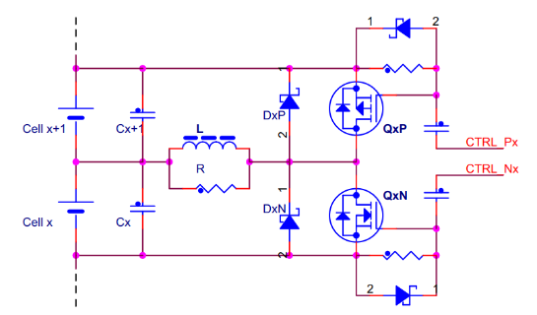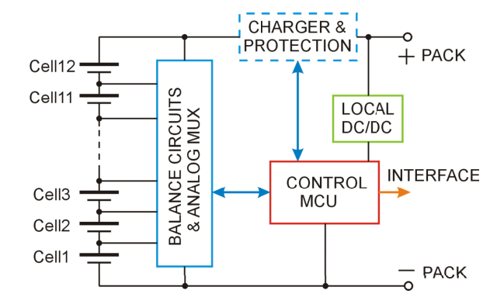

Capacitor-based cell balancing

Capacitor-based cell balancing (CBCB) uses capacitors to balance the charge between the cells. These are of the following types, namely single capacitor, switched capacitor and double-tiered switched capacitor.

A single capacitor is used to store and transfer the charge from the higher-capacity cell to the lower-capacity cell.

The working process is that in half of the cycle, the capacitor receives energy transfer from a higher voltage battery; in the other half of the cycle, the capacitor transfers the energy it received to a battery with a lower voltage. In the multiple-switched-capacitor equalization circuit, energy flows solely between two neighboring cells, resulting in a longer equalization time

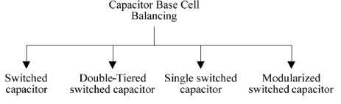

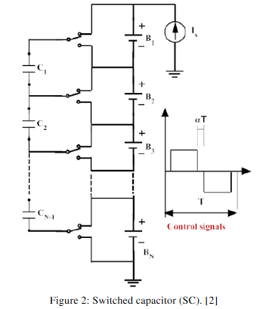 **Switched Capacitor**

Its control

strategy is simple because it has only two states.

In addition, it does not need intelligent control

and it can work in both recharging and

discharging

Its control

strategy is simple because it has only two states.

In addition, it does not need intelligent control

and it can work in both recharging and

discharging

Its control

strategy is simple because it has only two states.

In addition, it does not need intelligent control

and it can work in both recharging and

discharging

Its control

strategy is simple because it has only two states.

In addition, it does not need intelligent control

and it can work in both recharging and

discharging

Its control

strategy is simple because it has only two states.

In addition, it does not need intelligent control

and it can work in both recharging and

discharging

Its control strategy is simple because it has only two states. In addition, it does not need intelligent control and it can work in both recharging and discharging operation with high efficiency. The disadvantage of the switched capacitor topology is relatively long equalization time and more expensive than the switched shunt resistor balancing method

**Double-Tiered Capacitor**

This balancing method [14-16] is also a

derivation of the switched capacitor method, the

difference is that it uses two capacitor tiers for

energy shuttling as shown Fig. 3. It needs n

capacitor and 2n switches to balance n cells.

This balancing method [14-16] is also a

derivation of the switched capacitor method, the

difference is that it uses two capacitor tiers for

energy shuttling as shown Fig. 3. It needs n

capacitor and 2n switches to balance n cells.

This balancing method [14-16] is also a

derivation of the switched capacitor method, the

difference is that it uses two capacitor tiers for

energy shuttling as shown Fig. 3. It needs n

capacitor and 2n switches to balance n cells.

This balancing method [14-16] is also a

derivation of the switched capacitor method, the

difference is that it uses two capacitor tiers for

energy shuttling as shown Fig. 3. It needs n

capacitor and 2n switches to balance n cells.

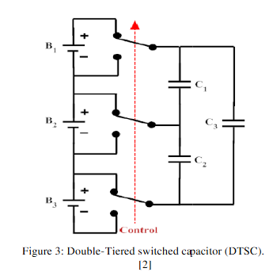

This balancing method also a derivation of the switched capacitor method, the difference is that it uses two capacitor tiers for energy shuttling as shown . More tiers means more paths between batteries, which yields less impedance to the transport of charge over a particular distance across the battery pack. The advantage of double-tiered switched capacitor more the switched capacitor method is that the second capacitor tier reduces the balancing time for more than a half. In addition, as the switched capacitor topology the double-tiered switched capacitor can work in both recharging and discharging operation.

**Single Switched Capacitor**

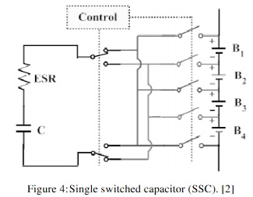

The single switched capacitor balancing topology can consider as a derivation of the switched capacitor, but it uses only one capacitor as shown.

A relatively simple control strategy is always used the controller selects the higher and the lower charge cells then controls the corresponding switches for shuttling the energy between them. However , more advanced control strategies can be used for fast the balancing speed.

**Modularization switched capacitor**

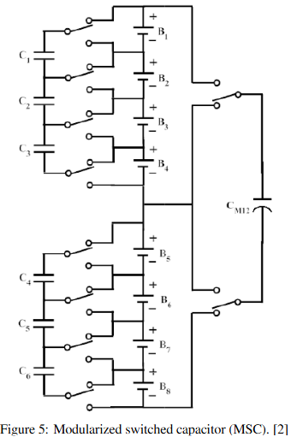

Another topology utilizes the switched capacitor method is based on battery pack modularization. It utilizes the modules technique by dividing the battery pack into modules; inside each module it treats with sub module cells with a separate equalization technique.